Draft ALRC Terms of Reference, ‘Copyright and the Digital Economy’
The Australian Digital Alliance and Australian Libraries Copyright Committee are grateful for the opportunity to comment on the Draft ALRC Terms of Reference – Copyright and the Digital Economy (Terms).
The Australian Digital Alliance (ADA) and Australian Libraries Copyright Committee (ALCC) believe the draft terms of reference enable the Australian Law Reform Commission to take a full and comprehensive review of scope and use of the exceptions contained in the Copyright Act 1968. We understand that the focus of the enquiry will be on these exceptions and on user rights under the Act, and that all areas of use and exceptions in the Act will be considered.
In view of Australia’s goal to become a leading digital economy by 2020, the ADA and ALCC commend the Inquiry’s broader focus on the ability of exceptions to foster and facilitate innovation and creativity in a digital environment, and the understanding therein of the significant contributions to economic and cultural development made possible by such innovation and creativity.
Comments on the Terms of Reference
We note that the terms of reference direct the ALRC to consider whether ‘further exceptions should be provided’ to facilitate new uses of copyright works, as part of their review of the appropriateness of existing exceptions in the digital environment.
It may be useful to make clear that the ALRC is to consider both ‘further’ exceptions to the Copyright Act, and amendments to existing exceptions that would enable greater flexibility of use of copyright works, and which achieve technology neutrality.
We are pleased that the draft terms of reference provide the ALRC with scope to consider further exceptions to the Copyright Act “amongst other things” that interact with exceptions to the Copyright Act. The ADA and ALCC understand these to include:
- Consideration of a broad, open-ended exception that may replace or supplement existing exceptions, to ‘facilitate legitimate use of copyright works to create and deliver new products and services of public benefit’.
- Consideration of the relationship between the statutory licences under Part VA and Part VB of the Copyright Act, and exceptions to copyright.

Concluding remarks
The ADA and ALCC approve the Government’s decision to exclude from the inquiry consideration of the scope of the safe harbour scheme for ISPs and exceptions relating to technological protection measures (TPMs). We have been participating in Attorney-General’s Department consultations in these areas, and look forward to further work being undertaken while the ALRC review is in process. We anticipate progress on reform of the safe harbour scheme in the very near future, and urge the Government to push forward in its review of TPMs without delay.
The ADA and ALCC are looking forward to engaging with the Commission in their inquiry. If you would like to discuss this comment further please contact Ellen Broad, copyright law and policy adviser for the ADA and ALCC on (02) 6262 1273 or by email at ebroad@nla.gov.au.

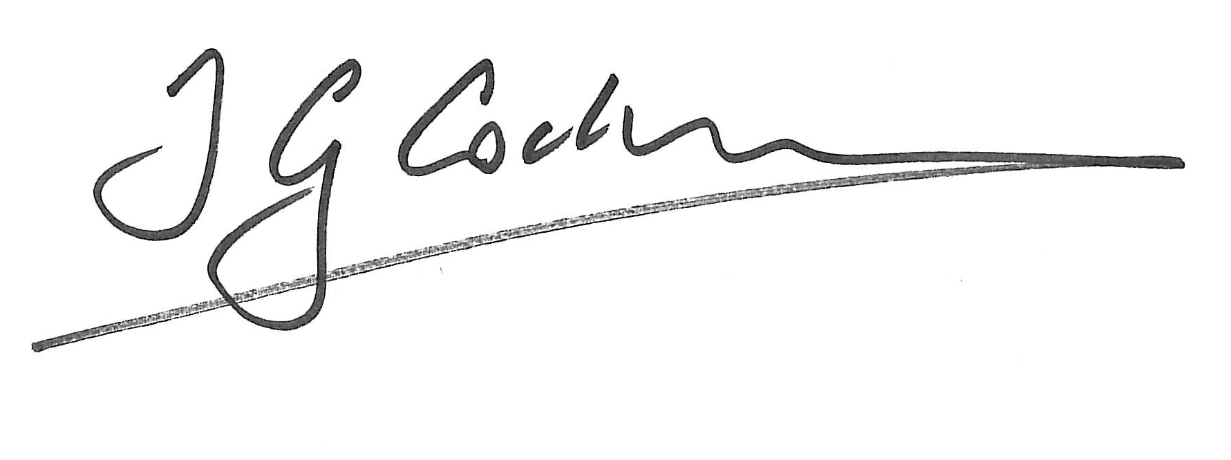
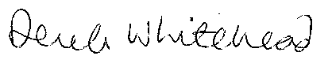

Professor Tom Cochrane Derek Whitehead OAM
Chairman Chairman
Australian Libraries Copyright Committee Australian Digital Alliance

About the Australian Digital Alliance (ADA)
The ADA is a non-profit coalition of public and private sector interests formed to promote balanced copyright law and provide an effective voice for a public interest perspective in the copyright debate. ADA members include universities, schools, consumer groups, galleries, museums, IT companies, scientific and other research organisations, libraries and individuals.
Whilst the breadth of ADA membership spans various sectors, all members are united in their support of copyright law that balances the interests of rights holders with the interests of users of copyright material.

About the Australian Libraries Copyright Committee (ALCC)
The ALCC is the main consultative body and policy forum for the discussion of copyright issues affecting Australian libraries and archives. It is a cross-sectoral committee which represents the following organisations:
- Australian Library and Information Association
- Australian Government Libraries Information Network
- Council of Australasian Archives and Records Authorities
- The Australian Society of Archivists
- Council of Australian University Librarians
- National Library of Australia
- National and State Libraries Australasia

